BABEŞ-BOLYAI UNIVERSITY CLUJ-NAPOCA

FACULTY OF MATHEMATICS AND COMPUTER SCIENCE

SPECIALIZATION COMPUTER SCIENCE

DIPLOMA THESIS

Procedural Content Generation in Games using Recurrent Neuronal Networks

Supervisor
Mircea Ioan-Gabriel,
Assistant

Author
Ivanov Silviu-Gabriel

2018
- Abstract

- Contents

- ABSTRACT . . . . . . . . . . . . . . . . . . . . 2
- CONTENTS . . . . . . . . . . . . . . . . . . . . 3
- INTRODUCTION . . . . . . . . . . . . . . . . . . . 4
- PROBLEM SPECIFICATION . . . . . . . . . . . . . . . 6
- PROCEDURAL CONTENT GENERATION . . . . . . . . . . . 7
  - Procedural Content Generation in Games . . . . . . . . . . . . 8
- MACHINE LEARNING . . . . . . . . . . . . . . . . . 10
  - Recurrent Neural Network . . . . . . . . . . . . . . . . 11
    - LSTM . . . . . . . . . . . . . . . . . . . 13
  - PCG using Machine Learning . . . . . . . . . . . . . . . 15
  - Benchmarks . . . . . . . . . . . . . . . . . . . . 17
- APPLICATION
  - Lode Runner . . . . . . . . . . . . . . . . . . . 20
  - Requirements . . . . . . . . . . . . . . . . . . . 22
  - Design . . . . . . . . . . . . . . . . . . . . . 23
    - System Representation . . . . . . . . . . . . . . . 24
    - Use Cases & Diagrams . . . . . . . . . . . . . . . 26
  - Implementation . . . . . . . . . . . . . . . . . . . 28
    - Code & Languages . . . . . . . . . . . . . . . . 29
    - Technologies . . . . . . . . . . . . . . . . . . 31
  - Validation & Testing . . . . . . . . . . . . . . . . .
- RESULTS . . . . . . . . . . . . . . . . . . . . .
- CONCLUSION . . . . . . . . . . . . . . . . . . . .
- DISCUSSION . . . . . . . . . . . . . . . . . . . .
- BIBLIOGRAPHY . . . . . . . . . . . . . . . . . . .
- APPENDIX . . . . . . . . . . . . . . . . . . . . .

- Introduction

- Problem Specification

- Procedural Content Generation
In computing, procedural generation is a method of creating data algorithmically as opposed to manually. In computer graphics, it is also called random generation and is commonly used to create textures and 3D models. In video games, it is used to automatically create large amounts of content in a game. Advantages of procedural generation include smaller file sizes, larger amounts of content, and randomness for less predictable gameplay.
The term procedural refers to the process that computes a particular function. Fractals are geometric patterns which can often be generated procedurally. Commonplace procedural content includes textures and meshes. Sound is often also procedurally generated and has applications in both speech synthesis as well as music. It has been used to create compositions in various genres of electronic music by artists such as Brian Eno who popularized the term "generative music". ^{[1]}
While software developers have applied procedural generation techniques for years, few products have employed this approach extensively. Procedurally generated elements have appeared in earlier video games: The Elder Scrolls II: Daggerfall takes place in a mostly procedurally generated world, giving a world roughly twice the actual size of the British Isles. Soldier of Fortune from Raven Software uses simple routines to detail enemy models, while its sequel featured a randomly-generated level mode. Avalanche Studios employed procedural generation to create a large and varied group of detailed tropical islands for Just Cause. No Man's Sky, a game developed by games studio Hello Games, is all based upon procedurally generated elements.
The modern demo scene uses procedural generation to package a great deal of audiovisual content into relatively small programs.
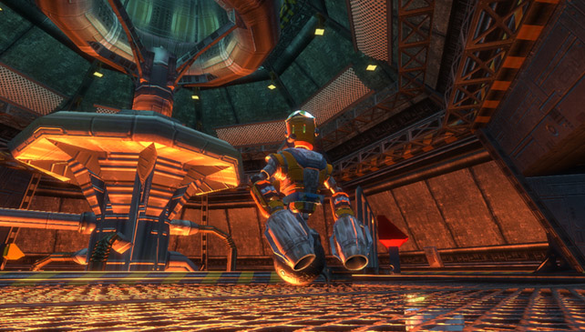
New methods and applications are presented annually in conferences such as the IEEE Conference on Computational Intelligence and Games and Artificial Intelligence and Interactive Digital Entertainment. ^{[2]}

  - Procedural Content Generation in Games
Prior to graphically oriented video games, roguelike games, including Beneath Apple Manor (1978) and the genre's namesake, Rogue (1980), used procedural generation to construct dungeons for ASCII- or regular tile-based systems. The procedural generation would define rooms, hallways, monsters, and treasure that the player would find. Roguelikes, and games based on the roguelike concepts, continue to be a popular genre, as it allows the development of complex gameplay without having to spend excessive time in creating a game's world.
The earliest graphical computer games were severely limited by memory constraints. This forced content, such as maps, to be generated algorithmically on the fly: there simply was not enough space to store a large amount of premade levels and artwork. Pseudorandom number generators were often used with predefined seed values in order to create very large game worlds that appeared to be premade.
The Sentinel supposedly had 10,000 different levels stored in only 48 and 64 kilobytes. An extreme case was Elite, which was originally planned to contain a total of 2⁴⁸ (approximately 282 trillion) galaxies with 256 solar systems each. However, the publisher was afraid that such a gigantic universe would cause disbelief in players, and eight of these galaxies were chosen for the final version.^{[4]} Other notable early examples include the 1985 game Rescue on Fractalus that used fractals to procedurally create, in real time, the craggy mountains of an alien planet and River Raid, the 1982 Activision game that used a pseudorandom number sequence generated by a linear feedback shift register in order to generate a scrolling maze of obstacles.
As computer hardware advanced and CDs became able to store thousands of times more data than was possible in the early 80s, using procedural generation to build large worlds became unnecessary. Game content, such as textures, and character and environment models, is often created by artists beforehand, to keep the quality of the content consistently high.
Storing unique designs in the game's memory, rather than producing multiple objects using similar guidelines, allows a variety of detailed models that are each substantially different. However, when each model needs to be designed by hand, a limited number of objects will exist. Some initial approaches to procedural synthesis attempted to solve this problem by shifting the burden of content generation from the artists to programmers who can create code that automatically generates different meshes according to input parameters.
Supposing, however, a single algorithm can be envisioned to generate a realistic-looking tree, the algorithm could be called to generate random trees, thus filling a whole forest at runtime, instead of storing all the vertices required by the various models. This would save storage media space and reduce the burden on artists, while providing a similar level of immersion to the player. This method would require far more processing power, but since CPUs are constantly increasing in speed this is becoming less of a hurdle.
Though modern computer games do not have the same memory and hardware restrictions that earlier games had, the use of procedural generation is frequently employed to create randomized games, maps, levels, characters, or other facets that are unique on each playthrough. ^{[5][6]}
In 2004, a PC first-person shooter called. Krieger was released that made heavy use of procedural synthesis: while quite short and very simple, the advanced video effects were packed into just 96 kilobytes. In contrast, many modern games have to be released on DVDs, often exceeding 2 gigabytes in size, more than 20,000 times larger. Naked Sky's RoboBlitz used procedural generation to maximize content in a less than 50 MB downloadable file for Xbox Live Arcade. Will Wright's Spore also makes use of procedural synthesis.
Procedural generation is often used in loot systems of quest-driven games, such as action role-playing games and massive multiplayer online role-playing games. Though quests may feature fixed rewards, other loot, such as weapons and armor, may be generated for the player based on the player-character's level, the quest's level, their performance in the quest, and other random factors. This often leads to loot having a rarity quality applied to reflect when the procedural generation system has produced an item with better-than-average attributes. For example, the Borderlands series is based on its procedural generation system which can create over a million unique guns and other equipment. ^{[7]}
Many open world or survival games procedurally create a game world from a random seed or one provided by the player, so that each playthrough is different. These generation systems create numerous pixel- or voxel-based biomes with distribution of resources, objects, and creatures. The player frequently has the ability to adjust some of the generation parameters, such as specifying the amount of water coverage in a world. Examples of such games include Dwarf Fortress and Minecraft. An artifact of the procedural generation around these games is that if the space that the player is allowed to explore is not limited, the randomness of the procedural generation will start to produce more noise than content; this is exemplified in the idea of the "Far Lands" within some earlier versions of Minecraft, where the usual smooth transitions between biomes was replaced with haphazard formations. ^{[8]}
Procedural generation is also used in open-world games of very large scale, particularly in space flight simulator games. Elite: Dangerous, though using the 400 billion known stars of the Milky Way Galaxy as its world basis, uses procedural generation to simulate the planets in these solar systems. Similarly, Star Citizen utilizes the technology for its planets, to create a collection of seamlessly-loaded planet-sized planets among its hand-crafted universe. I-Novae Infinity features a plethora of planets which are procedurally generated between which the player can travel via space ships. Outerra Anteworld is a video game in development that uses procedural generation and real-world data to create a virtual replica of planet Earth in true scale. No Man's Sky features a universe containing 18 quintillion planets which are procedurally generated on the fly as the player encounters them, including their terrain, weather, flora, and fauna, as well as a number of space-faring alien species. This universe is defined by the use of a single random seed number to their deterministic engine, assuring that the same content will be generated at the same places for all players, which enables players to share discoveries using only knowledge of the locations of the planets in the virtual galaxy. ^{[9] [10]}
Games that feature co-operative play may use procedural generation to craft unique experiences for the players as they complete the game. The Left 4 Dead series, based on a zombie apocalypse setting, uses an AI Director, an artificial intelligence that monitors the behavior of the players and creates a dynamic experience to keep players alert. It can sense when players have become comfortable and spawn new zombies and hordes to attack the players in mid-level and alter which routes are available for players to take. Similar concepts are used for games like Warhammer: End Times – Vermintide. ^{[11]}
- Machine Learning
Machine learning is a field of computer science that uses statistical techniques to give computer systems the ability to "learn" (e.g., progressively improve performance on a specific task) with data, without being explicitly programmed. ^{[12]}
The name machine learning was coined in 1959 by Arthur Samuel. Evolved from the study of pattern recognition and computational learning theory in artificial intelligence, machine learning explores the study and construction of algorithms that can learn from and make predictions on data – such algorithms overcome following strictly static program instructions by making data-driven predictions or decisions, through building a model from sample inputs. Machine learning is employed in a range of computing tasks where designing and programming explicit algorithms with good performance is difficult or infeasible; example applications include email filtering, detection of network intruders or malicious insiders working towards a data breach, optical character recognition (OCR), learning to rank, and computer vision.
Machine learning is closely related to (and often overlaps with) computational statistics, which also focuses on prediction-making through the use of computers. It has strong ties to mathematical optimization, which delivers methods, theory and application domains to the field. Machine learning is sometimes conflated with data mining, where the latter subfield focuses more on exploratory data analysis and is known as unsupervised learning. Machine learning can also be unsupervised and be used to learn and establish baseline behavioral profiles for various entities and then used to find meaningful anomalies.
Within the field of data analytics, machine learning is a method used to devise complex models and algorithms that lend themselves to prediction; in commercial use, this is known as predictive analytics. These analytical models allow researchers, data scientists, engineers, and analysts to "produce reliable, repeatable decisions and results" and uncover "hidden insights" through learning from historical relationships and trends in the data.
In addition to performance bounds, computational learning theorists study the time complexity and feasibility of learning. In computational learning theory, a computation is considered feasible if it can be done in polynomial time. There are two kinds of time complexity results. Positive results show that a certain class of functions can be learned in polynomial time. Negative results show that certain classes cannot be learned in polynomial time.
  - Recurrent Neural Networks
A recurrent neural network (RNN) is a class of artificial neural network where connections between units form a directed graph along a sequence. This allows it to exhibit dynamic temporal behavior for a time sequence. Unlike feedforward neural networks, RNNs can use their internal state (memory) to process sequences of inputs. This makes them applicable to tasks such as unsegmented, connected handwriting recognition or speech recognition.
The term "recurrent neural network" is used indiscriminately to refer to two broad classes of networks with a similar general structure, where one is finite impulse and the other is infinite impulse. Both classes of networks exhibit temporal dynamic behavior. A finite impulse recurrent network is a directed acyclic graph that can be unrolled and replaced with a strictly feedforward neural network, while an infinite impulse recurrent network is a directed cyclic graph that cannot be unrolled.
Both finite impulse and infinite impulse recurrent networks can have additional stored state, and the storage can be under direct control by the neural network. The storage can also be replaced by another network or graph, if that incorporates time delays or has feedback loops. Such controlled states are referred to as gated state or gated memory and are part of Long short-term memory’s (LSTM) and gated recurrent units.
Gradient descent is a first-order iterative optimization algorithm for finding the minimum of a function. In neural networks, it can be used to minimize the error term by changing each weight in proportion to the derivative of the error with respect to that weight, provided the non-linear activation functions are differentiable. Various methods for doing so were developed in the 1980s and early 1990s by Werbos, Williams, Robinson, Schmid Huber, Hoch Reiter, Perlmutter and others.
The standard method is called "backpropagation through time" or BPTT and is a generalization of back-propagation for feed-forward networks. Like that method, it is an instance of automatic differentiation in the reverse accumulation mode of Pentraxin’s minimum principle. A more computationally expensive online variant is called "Real-Time Recurrent Learning" or RTRL, which is an instance of automatic differentiation in the forward accumulation mode with stacked tangent vectors. Unlike BPTT, this algorithm is local in time but not local in space.
In this context, local in space means that a unit's weight vector can be updated using only information stored in the connected units and the unit itself such that update complexity of a single unit is linear in the dimensionality of the weight vector. Local in time means that the updates take place continually (on-line) and depend only on the most recent time step rather than on multiple time steps within a given time horizon as in BPTT. Biological neural networks appear to be local with respect to both time and space.
For recursively computing the partial derivatives, RTRL has a time-complexity of O (number of hidden x number of weights) per time step for computing the Jacobian matrices, while BPTT only takes O (number of weights) per time step, at the cost of storing all forward activations within the given time horizon. An online hybrid between BPTT and RTRL with intermediate complexity exists, along with variants for continuous time.
A major problem with gradient descent for standard RNN architectures is that error gradients vanish exponentially quickly with the size of the time lag between important events. LSTM combined with a BPTT/RTRL hybrid learning method attempts to overcome these problems.
The on-line algorithm called causal recursive backpropagation (CRBP), implements and combines BPTT and RTRL paradigms for locally recurrent networks. It works with the most general locally recurrent networks. The CRBP algorithm can minimize the global error term. This fact improves stability of the algorithm, providing a unifying view on gradient calculation techniques for recurrent networks with local feedback.
One approach to the computation of gradient information in RNNs with arbitrary architectures is based on signal-flow graphs diagrammatic derivation. It uses the BPTT batch algorithm, based on Lee's theorem for network sensitivity calculations. It was proposed by Wan and Beaufays, while its fast-online version was proposed by Campolucci, Uncini and Piazza.
    - LSTM

  - PCG using Machine Learning

  - Benchmarks

  - Lode Runner
  - Requirements
The input is text file of the original Mario levels. There are two different sequences
that can be derived from this file. First is the character sequence. This sequence
simply consist of all the characters in the file including the new line character. The
new line character states when a new column starts. The other sequence is the
column sequence. Instead of looking at every single character the input is split at
the new line characters, the result is a list that is a sequence of all the columns in
the text files. This means that the levels generated from column subsequences are
limited to only contain columns found in the dataset. The system will work with
columns or characters as tokens.
In both cases the input is processed the same way. A set is created of all the
different tokens. By enumerating this set two dictionaries are created that translate
index to token and token to index. The next step is cutting the input into smaller
sequences of variable length. Two parameters are involved here. First there is
the length of subsequences. Secondly there is the step between the start of each
subsequences. For example, the string “abcdefg” with length=3 and step=2 will
result in” abc”,” cde” and” efg”. For every of these subsequences the subsequent
token is stored as a label of this subsequence. The final step of preparing the input
is vectorization. Vectorization transforms all the input tokens into one hot vectors.
These are vectors with length equal to all possible tokens where all values are 0
except the one value associated to that particular token. The vectorization of the
array of subsequences and the array of corresponding subsequent tokens leaves the
final input shape. The first will act as the input data, the second as the associated
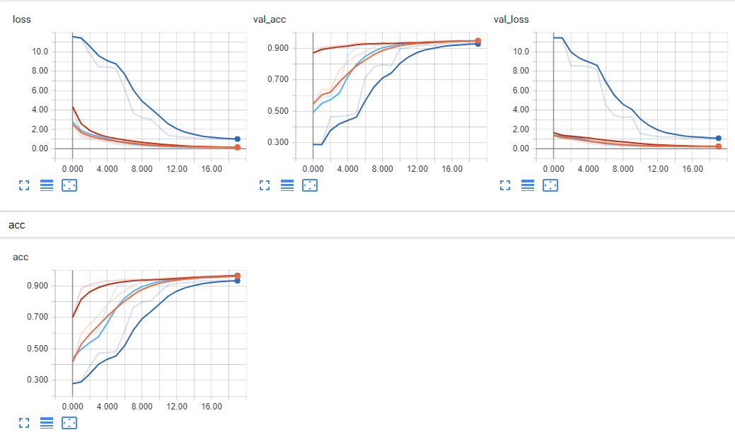
labels.
The model used is a sequential model in Keras with one LSTM layer, one Dense
layer and an Activation layer. The Dense layer is used to get the output in the right
format which is a vector with the same length as the token set. The softmax Activation
layer makes the output add up to 1 so that the output can be interpreted as
probabilities. This makes the output a vector with probabilities for every different
token in the token set. The model is compiled to make use of” categorical cross
entropy” also known as” multi class log loss” as a loss function. This loss function
is recommended when dealing with classification problems such as predicting the
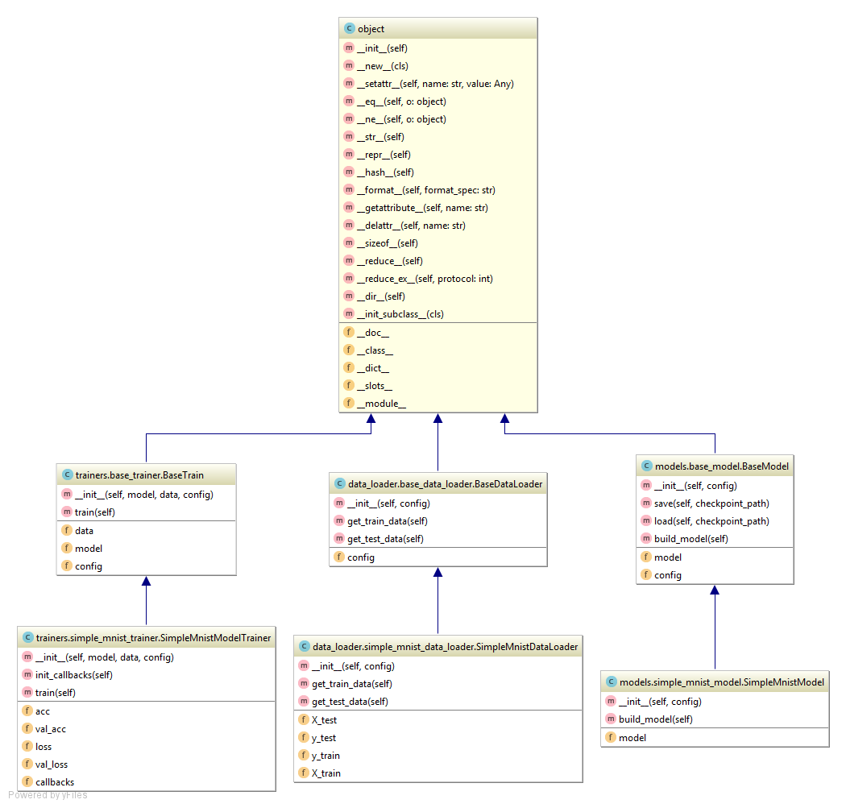
next token in a sequence.

- Bibliography
[1] Dahlskog, S., & Togelius, J. (2014). A multi-level level generator. 2014 IEEE Conference on Computational Intelligence and Games. doi:10.1109/cig.2014.6932909
[2] Togelius, J., Justinussen, T., & Hartzen, A. (2012). Compositional procedural content generation. Proceedings of the The Third Workshop on Procedural Content Generation in Games - PCG12. doi:10.1145/2538528.2538541
[3] Russell, S. J., & Norvig, P. (2016). Artificial intelligence: A modern approach. Upper Saddle River: Pearson.
[4] Goodfellow, I., Bengio, Y., & Courville, A. (2017). Deep learning. Cambridge, MA: MIT Press.
[5] Dahlskog, S., Togelius, J., & Nelson, M. J. (2014). Linear levels through n-grams. Proceedings of the 18th International Academic MindTrek Conference on Media Business, Management, Content & Services - AcademicMindTrek 14. doi:10.1145/2676467.2676506
[6] Julian Togelius, Mark J. Nelson, Alex J, Champandard (2013). Procedural Content Generation: Goals, Challenges and Actionable Steps
[7] Bengio, Y., Simard, P., & Frasconi, P. (1994). Learning long-term dependencies with gradient descent is difficult. IEEE Transactions on Neural Networks,5(2), 157-166. doi:10.1109/72.279181
[8] Shaker, N., Nicolau, M., Yannakakis, G. N., Togelius, J., & Oneill, M. (2012). Evolving levels for Super Mario Bros using grammatical evolution. 2012 IEEE Conference on Computational Intelligence and Games (CIG). doi:10.1109/cig.2012.6374170
[9] Desurvire, H., Caplan, M., & Toth, J. A. (2004). Using heuristics to evaluate the playability of games. Extended Abstracts of the 2004 Conference on Human Factors and Computing Systems - CHI 04. doi:10.1145/985921.986102
[10] Mcguinness, C., & Ashlock, D. (2011). Decomposing the level generation problem with tiles. 2011 IEEE Congress of Evolutionary Computation (CEC). doi:10.1109/cec.2011.5949707
[11] Smith, G., & Whitehead, J. (2010). Analyzing the expressive range of a level generator. Proceedings of the 2010 Workshop on Procedural Content Generation in Games - PCGames 10. doi:10.1145/1814256.1814260
[12] Otte, P. (1995). Lode runner: The legend returns: The official guide to the Evil Empire. Rocklin, CA: Prima Pub.
[13] G. (n.d.). Understanding Computer Role-Playing Games. Retrieved from https://mafiadoc.com/understanding-computer-role-playing-games_59b811251723dddbc635a5bd.html
[14] Björk, S., & Holopainen, J. (2006). Patterns in game design. Boston, MA: Charles River Media.
[15] Gamma, E. (1995). Design patterns elements of reusable object-oriented. Boston: Addison-Wesley.

